**JOBSHEET 1**

**FRAMEWORK-BASED PROGRAMMING**



By:

DAFFA USMAN

NIM : 1941720084

**PROGRAM STUDI D-IV TEKNIK INFORMATIKA**

**JURUSAN TEKNOLOGI INFORMASI**

**POLITEKNIK NEGERI MALANG**

**2022**

Experiment A

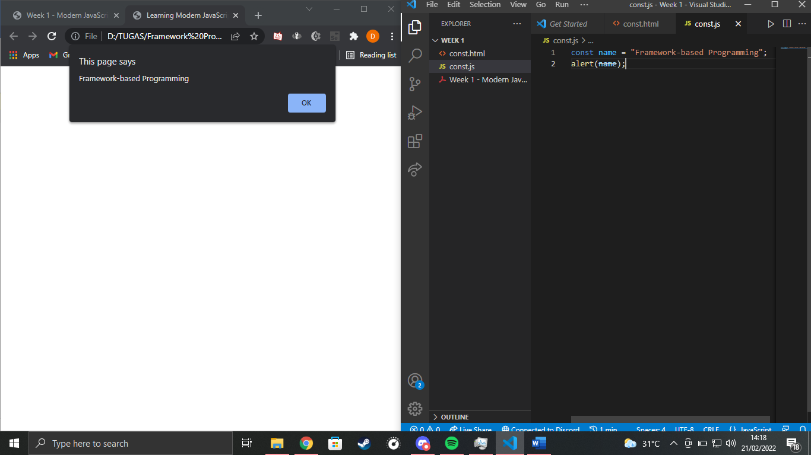

The web outputs like that because from the const.js file there is a variable named const with value “Framework-based Programming” and after that the program calls an alert with parameter const.

Experiment B

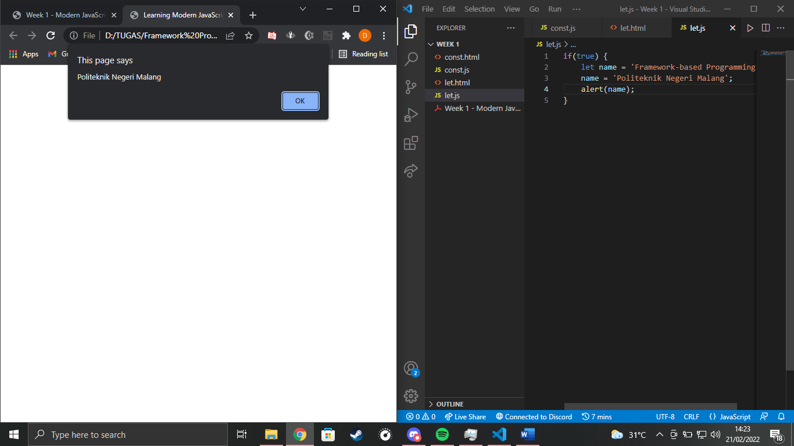

The program outputs an alert with text “Politeknik Negeri Malang”. From the start the variable let was initiated with value “Framework-based Programming” but then it’s changed to “Politeknik Negeri Malang”.

Experiment C

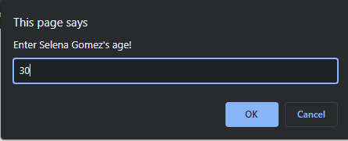

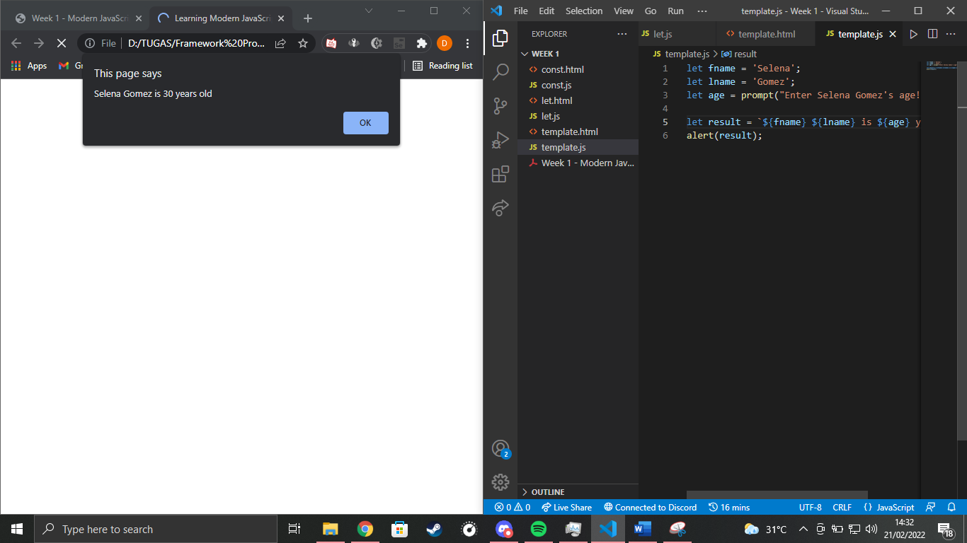

The ‘result’ variable can get a value from the prompt, and it can also print another variable’s value with the dollar sign.

Experiment D

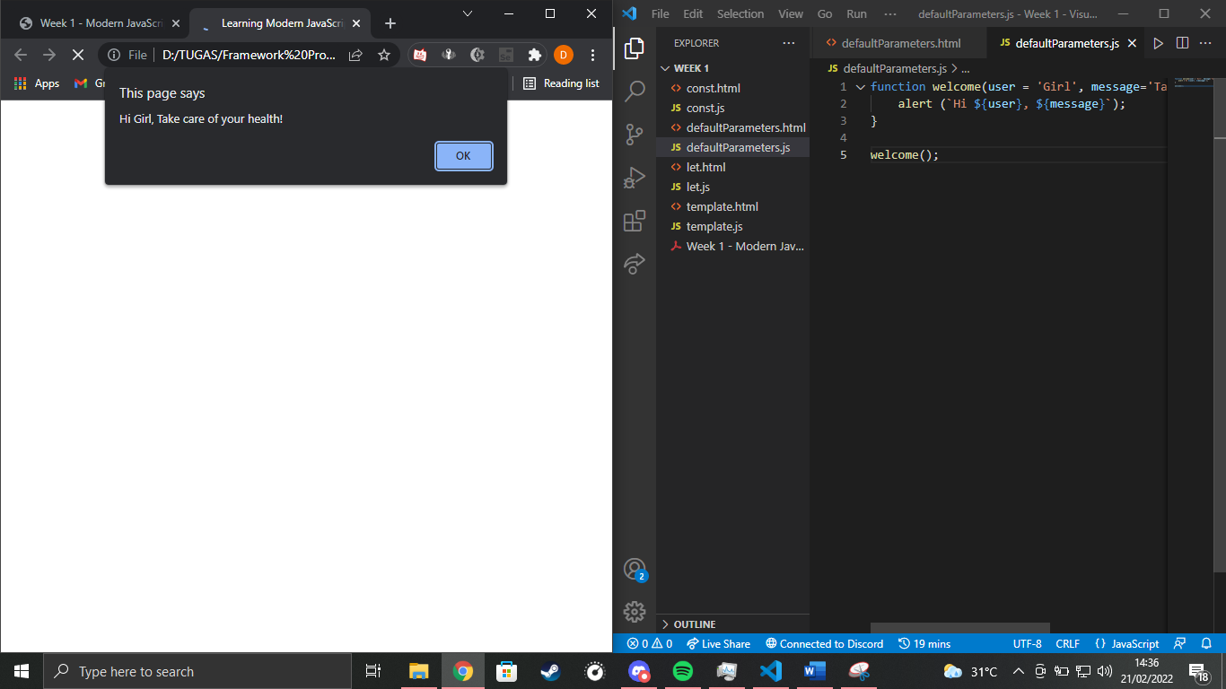

This fuction let us create an alert message with user and message variable. We initiated the value from the parameter and we just call them in the method using the dollar sign.

Experiment E

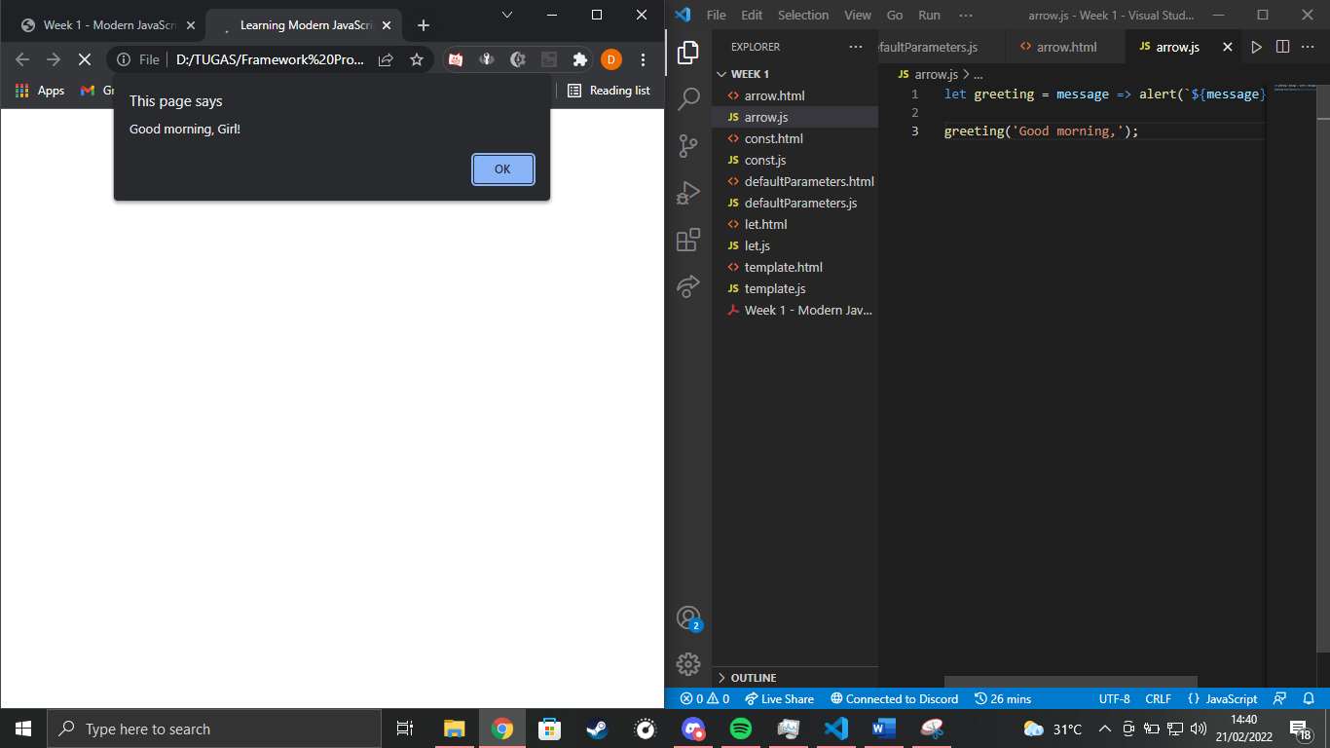

The greeting variable is a message variable which calls its own value plus some other values.

Experiment F

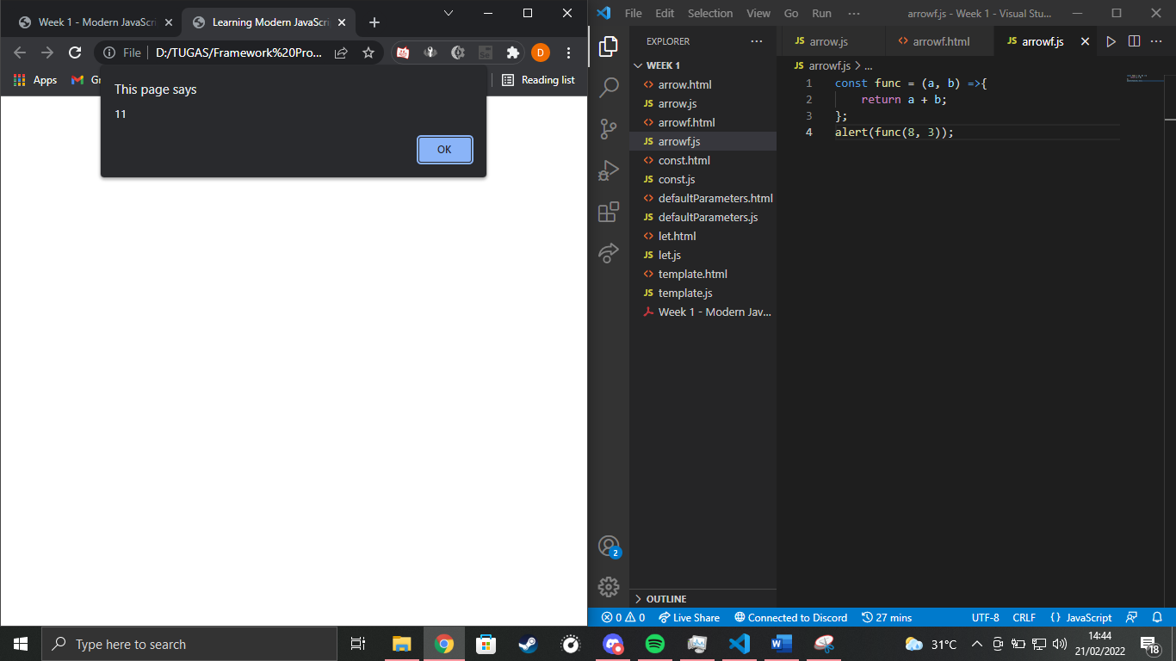

The const function is an addition function which is going to add any value inputted to the parameter.

Experiment G

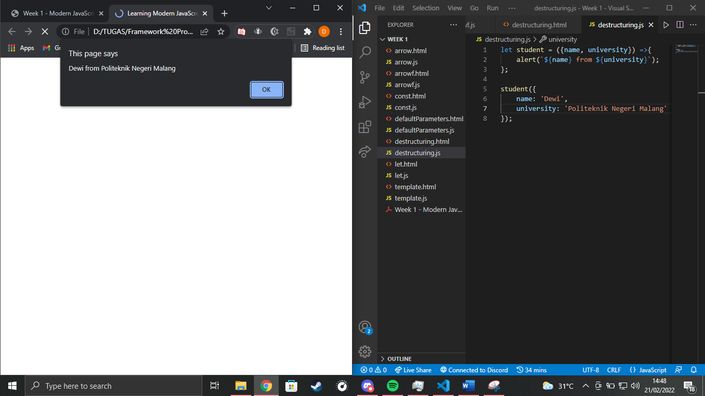

The first 3 lines are a function to print an alert, and then we declare the value of student variable in the last 4 lines.

Experiment H

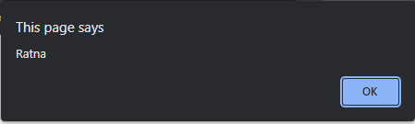

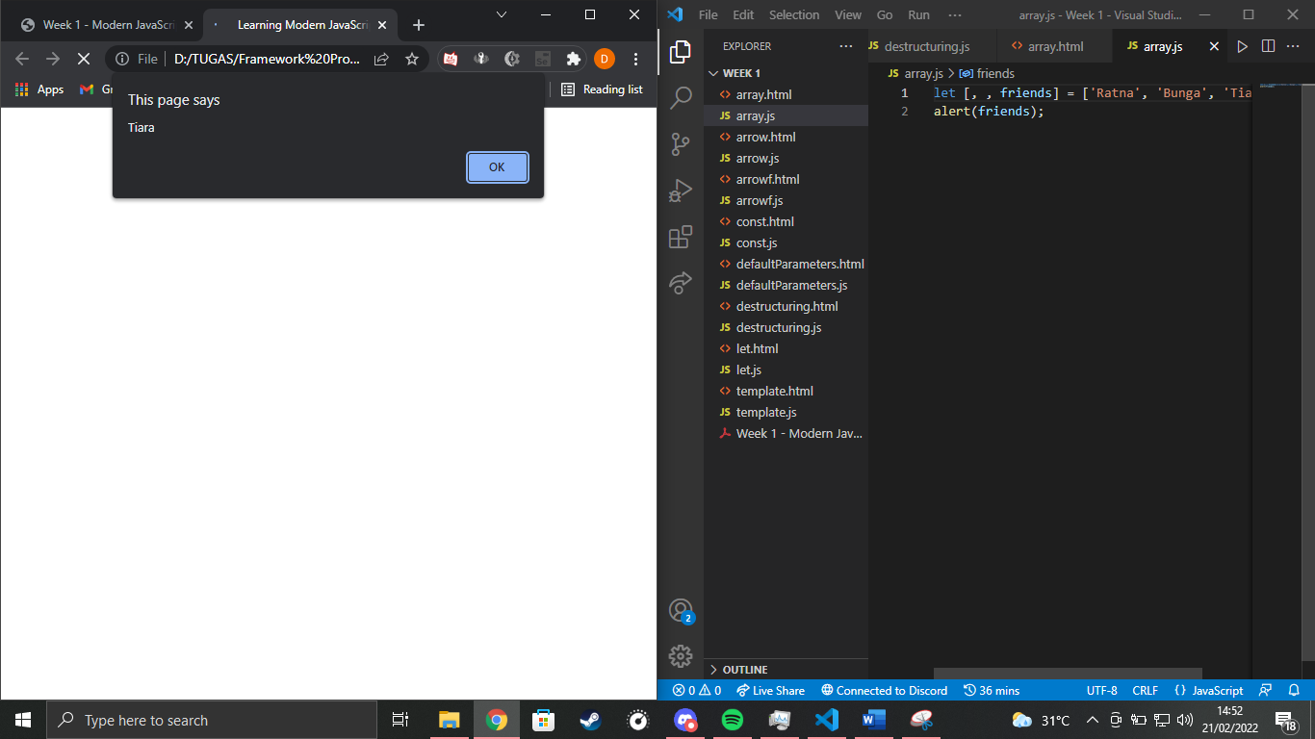

This is a way to print a specific index in an array.

Experiment I

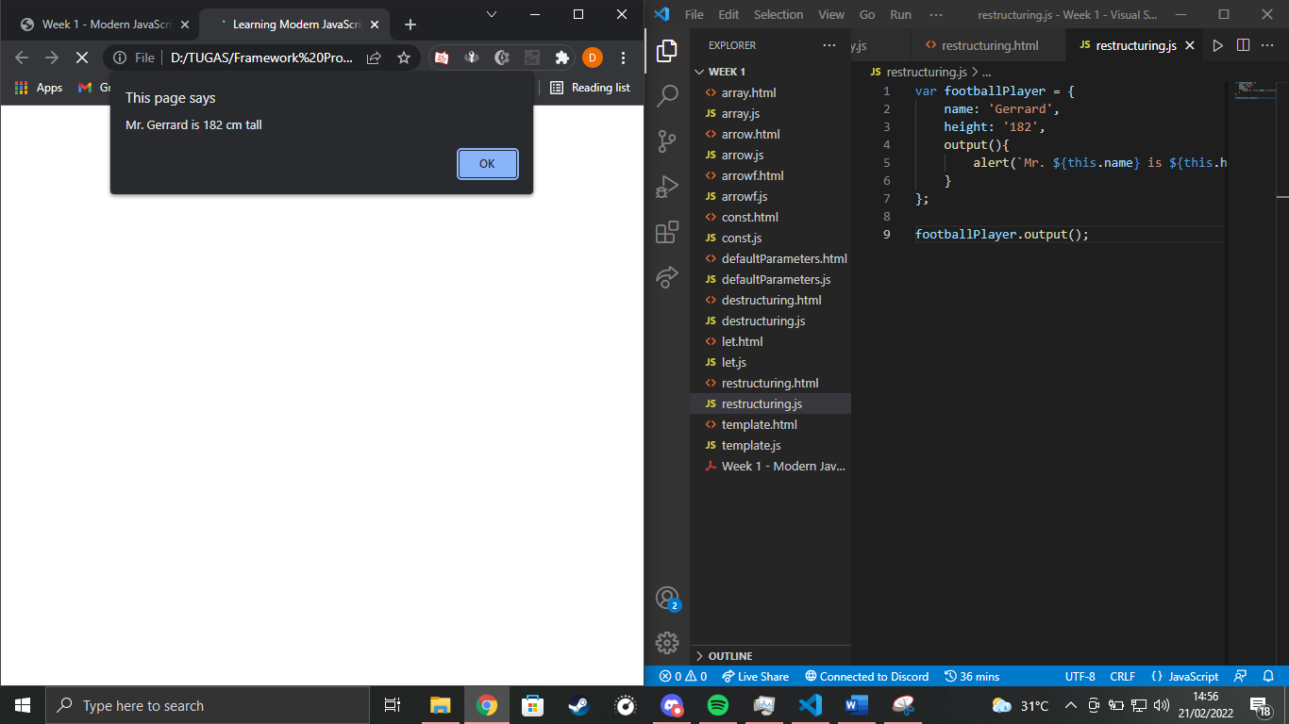

There’s an output method in the footballPlayer var to restructure all the attributes stored and make an alert to print all those attributes at once.

Experiment J

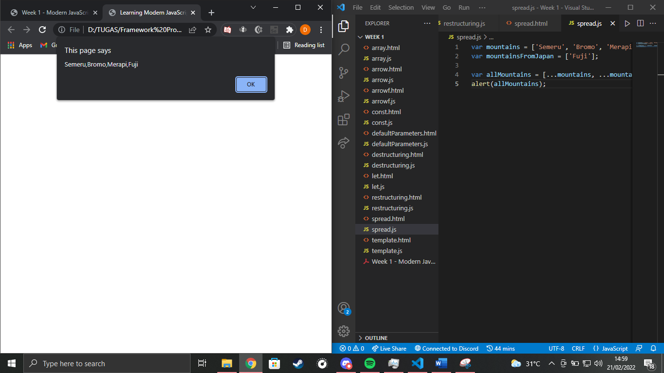

We use the triple dots to print all values stored in an array.

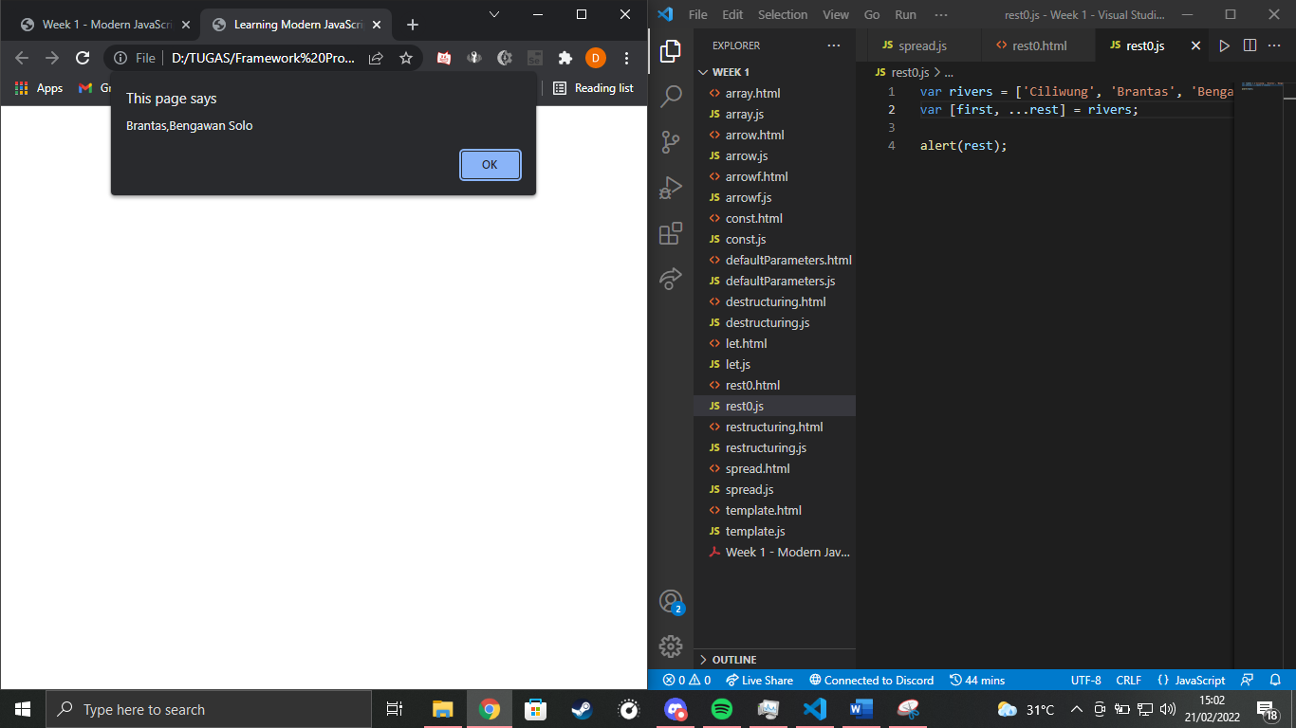

We use …rest to print the last (n) indexes in an array.

Experiment K

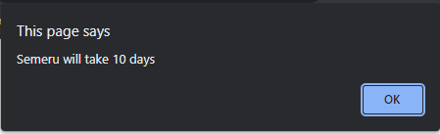

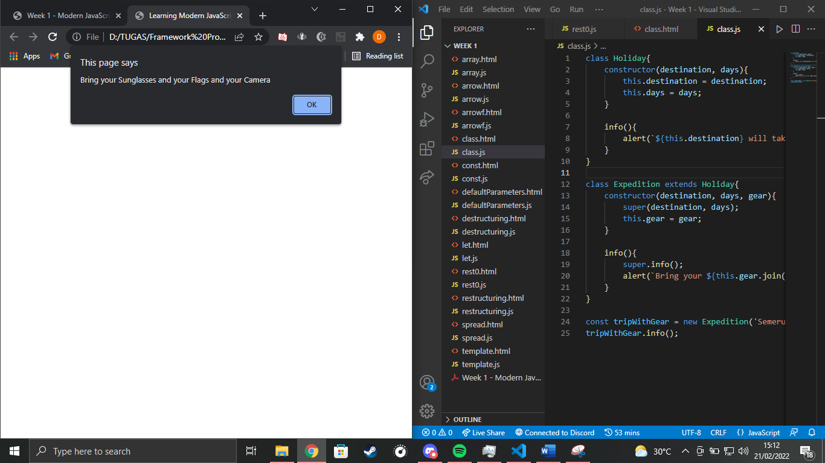

The superclass has 2 initiated attributes and 1 method, meanwhile the subclass has one more additional attribute and a modificated method. The tripWithGear object was inherited from the expedition class and it calls all attributes and methods from it.